DISHES AND THEIR ALLERGEN CONTENT – Homemade@Haddenham St Mary’sMAIN DISHES – Spring 1 2020
All free from menu options are free from gluten and dairy products – for further information please email homemade@haddenham-st-marys.bucks.sch.uk
DISHES | 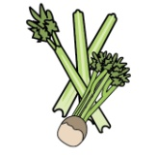 | 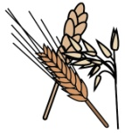 | 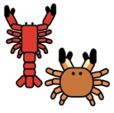 |  |  |  |  |  |  |  | 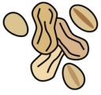 | 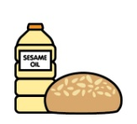
 | Celery | Cereals containing gluten | Crustaceans | Eggs | Fish | Lupin | Milk | Mollusc | Mustard | Nuts | Peanuts | Sesame seeds | Soya | Sulphur Dioxide
‘Free from’ fish fingers, new potatoes/chips/  croquettes and vegetables |  |  |  |  | ✓
Breaded fish, chips and vegetables |  | ✓ |  | ✓ | ✓ |  | ✓
Chicken goujons, new potatoes/wedges/chips and vegetables |  | ✓ |  | ✓ |  |  | ✓
Chicken Kiev, potato rosti and vegetables |  | ✓ |  | ✓ |  |  | ✓
Chilli, rice and nachos |  | ✓ |  | ✓ |  |  | ✓
Falafel roast dinner |  | ✓ |  | ✓ |  |  | ✓
Fish burger, chips/potato lattice/potatoes and vegetables |  | ✓ |  | ✓ | ✓ |  | ✓
Fish cake, chips and vegetables |  | ✓ |  | ✓ | ✓ |  | ✓
Jacket potato with a choice of fillings |  |  |  |  | ✓ |  | ✓
Meatballs and spaghetti |  | ✓ |  | ✓ |  |  | ✓
Mediterranean chicken and rice |  | ✓
Mediterranean vegetables and rice |  | ✓
Quorn roast dinner |  | ✓ |  | ✓ |  |  | ✓
Roast beef dinner |  | ✓ |  | ✓ |  |  | ✓
Roast turkey dinner |  | ✓ |  | ✓ |  |  | ✓
Sausage, mash and vegetables |  | ✓ |  | ✓ |  |  | ✓ |  |  |  |  |  |  | ✓
Sweet and sour chicken |  | ✓ |  | ✓
Sweet and sour vegetables |  | ✓ |  | ✓
Turkey pastichio |  | ✓ |  | ✓ |  |  | ✓
Vegetable chilli, rice and nachos |  | ✓ |  | ✓ |  |  | ✓
Vegetable fingers, new potatoes/chips/ croquettes/rosti and vegetables |  | ✓ |  | ✓ |  |  | ✓
Vegetable sausage roast dinner |  | ✓ |  | ✓ |  |  | ✓ |  |  |  |  |  |  | ✓
Vegetable slice, potato lattice/chips and vegetables |  | ✓ |  | ✓ |  |  | ✓
Veggie burger, potato rost/latticei and vegetables |  | ✓ |  | ✓ |  |  | ✓
Veggie Kiev, potato rosti and vegetables |  | ✓ |  | ✓ |  |  | ✓
Veggie meatballs and spaghetti |  | ✓ |  | ✓ |  |  | ✓
Veggie pastichio |  | ✓ |  | ✓ |  |  | ✓
Veggie sausage, mash and vegetables |  | ✓ |  | ✓ |  |  | ✓ |  |  |  |  |  |  | ✓

Review date: 25/11/2019 |  | Reviewed by: | J Higgins |  | You can find this template, including more information at www.food.gov.uk/allergy

