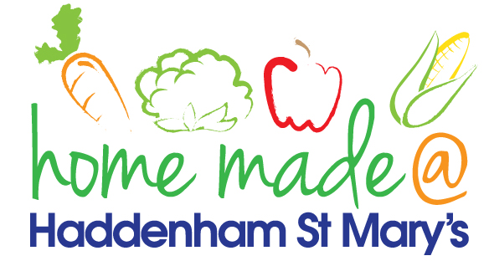

MENU – week 2
 | Monday  Around the World | Tuesday  Family  Favourites | Wednesday  Wonderful Roast | Thursday  Julie’s Jackets | Friday  Fish Friday
Lunch | Tomato pasta bake, garlic bread and salad | Sausages, mash  and vegetables | Roast beef with all the trimmings and gravy | Jacket potato with a choice of toppings | Fish burger, potato wedges and vegetables
Vegetarian option | Tomato pasta bake, garlic bread and salad | Vegetarian sausages, mash and vegetables | Veggie sausage roast with all the trimmings | Jacket potato with a choice of toppings | Veggie burger, potato wedges and vegetables
Dessert | Peach | Cheesecake | Fresh fruit | Chocolate pudding | Fruit muffin
Free From  option | Tomato pasta bake and salad  Peach | Chicken breast, mash and vegetables  Yoghurt | Roast beef with all the trimmings and gravy  Fresh fruit | Jacket potato with a choice of toppings  Flapjack | Fish fingers, potato wedges and vegetables  Cake
All meals will contain or be served with at least one portion of vegetables.
All hot puddings will be accompanied by custard or cream.
All roast dinners, sausage & mash and pie dishes will have the option of extra gravy.
All children will also be offered bread, a piece of fruit and a drink of milk or water with their main meal.

