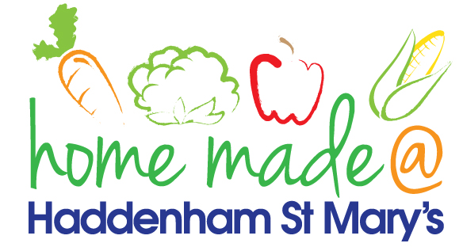

MENU – Week 1
 | Monday  Around the World | Tuesday  Family  Favourites | Wednesday  Wonderful Roast | Thursday  Julie’s Jackets | Friday  Fish Friday
Lunch | Pasta and meatballs | Hotdog, chips and coleslaw | Roast turkey with all the trimmings and gravy | Jacket potato with a choice of toppings | Breaded fish, new potatoes and vegetables
Vegetarian option | Vegetable pasta | Veggie hotdog, chips and coleslaw | Quorn roast with all the trimmings | Jacket potato with a choice of toppings | Vegetable  fingers, new potatoes and vegetables
Dessert | Mandarin segments | Trifle | Fresh fruit | Peach crumble | Homemade biscuit
Free From  option | Pasta and meatballs  Mandarin segments | Hotdog, chips and vegetables  Yoghurt | Roast turkey with all the trimmings and gravy  Fresh fruit | Jacket potato with a choice of toppings  Cake | Fish fingers, new potatoes and vegetables  Biscuit
All meals will contain or be served with at least one portion of vegetables.
All hot puddings will be accompanied by custard or cream.
All roast dinners, sausage & mash and pie dishes will have the option of extra gravy.
All children will also be offered bread, a piece of fruit and a drink of milk or water with their main meal.

