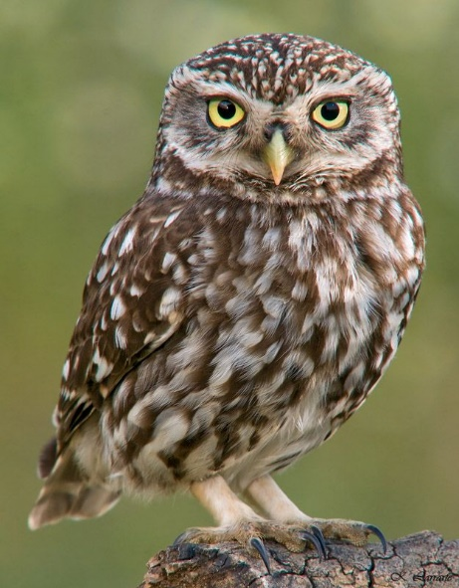**Little Owls Prayer:**

**Theme – Special Days:**

Dear Jesus,

We want to thank you for all the special days in our lives:

Thank you for the start of something new days such as; starting school or starting swimming lessons.

Our birthdays and that we can celebrate with our family and friends giving and getting presents. For Easter, Christmas and the Christmas café. Thank you for the stickers we get at the doctors and dentist. Thank you for the special day our baby brothers and sisters are born, for engagements and weddings, for holidays in hotels with big swimming pools. We are grateful for Whizz Kids, McDonalds, going out for dinner where there is a play area and yummy food. Thank you for sunny days especially in winter, snow days where we can make a snowman and go sledding and skiing. And finally thank you for day trips to the museum, fishing trips and going to the park with our families.

Amen