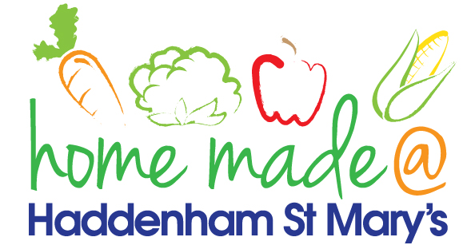

MENU – week commencing 14/10/2019
 | Monday  Around the world | Tuesday  Family  Favourites | Wednesday  Wonderful Roast | Thursday  Julie’s Jackets | Friday  Fish Friday
Lunch | Turkey curry and rice | Tacos, rice and salad | Roast beef with all the trimmings and gravy | Jacket potato with a choice of toppings | Fish burgers, potato lattice and peas
Vegetarian option | Vegetable curry and rice | Veggie tacos, rice and salad | Quorn roast with all the trimmings | Jacket potato with a choice of toppings | Vegetable slice, potato lattice and peas
Dessert | Mandarin segments | Mousse | Fresh fruit | Carrot cake | Oat and raisin cookie
Free From  option | Turkey curry and rice  Mandarin segments | Tacos, rice and salad  Mousse/yoghurt | Roast beef with all the trimmings and gravy  Fresh fruit | Jacket potato with a choice of toppings  Cake | Fish fingers, chips and peas  Biscuit
All meals will contain or be served with at least one portion of vegetables.
All hot puddings will be accompanied by custard or cream.
All roast dinners, sausage & mash and pie dishes will have the option of extra gravy.
All children will also be offered bread, a piece of fruit and a drink of milk or water with their main meal.

