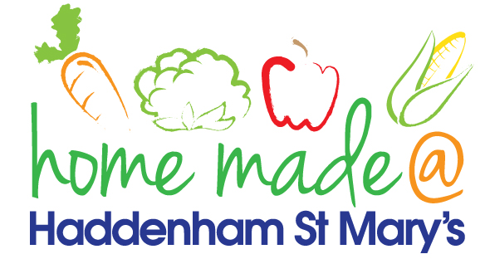

MENU – Week Commencing 02/09/2019
 | Monday  Around the World | Tuesday  Family  Favourites | Wednesday  Wonderful Roast | Thursday  Julie’s Jackets | Friday  Fish Friday
Lunch |  |  | Roast beef with all the trimmings and gravy | Jacket potato with a choice of toppings | Breaded salmon, new potatoes and vegetables
Vegetarian option |  |  | Quorn roast with all the trimmings | Jacket potato with a choice of toppings | Vegetable  fingers, chips and vegetables
Dessert |  |  | Fresh fruit | Muffins | Homemade biscuit
Free From  option |  |  | Roast beef with all the trimmings and gravy  Fresh fruit | Jacket potato with a choice of toppings  Fresh fruit | Fish fingers, chips and vegetables  Biscuit
All meals will contain or be served with at least one portion of vegetables.
All hot puddings will be accompanied by custard or cream.
All roast dinners, sausage & mash and pie dishes will have the option of extra gravy.
All children will also be offered bread, a piece of fruit and a drink of milk or water with their main meal.

