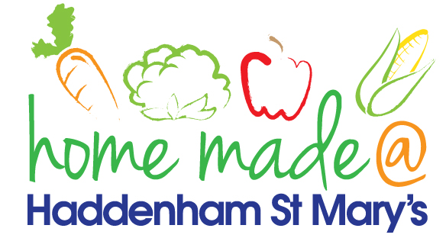

MENU – week 4
 | Monday  Around the world | Tuesday  Family  Favourites | Wednesday  Wonderful Roast | Thursday  Julie’s Jackets | Friday  Fish Friday
Lunch | Chilli, rice and nachos | Beef burger, potato rosti and salad | Roast turkey with all the trimmings and gravy | Jacket potato with a choice of toppings | Cod bites, potato croquettes and vegetables
Vegetarian option | Veggie chilli, rice and nachos | Veggie burger, potato rosti and salad | Veggie sausage roast with all the trimmings | Jacket potato with a choice of toppings | Vegetable bites, potato croquettes and vegetables
Dessert | Peach | Trifle | Fresh fruit | Toffee cake | Flapjack
Free From  option | Chilli, rice and nachos  Peach | Beef burger, potato rosti and vegetables  Mousse/yoghurt | Roast turkey with all the trimmings and gravy  Fresh fruit | Jacket potato with a choice of toppings  Toffee Cake | Fish fingers, potato croquettes and vegetables  Flapjack
All meals will contain or be served with at least one portion of vegetables.
All hot puddings will be accompanied by custard or cream.
All roast dinners, sausage & mash and pie dishes will have the option of extra gravy.
All children will also be offered bread, a piece of fruit and a drink of milk or water with their main meal.

