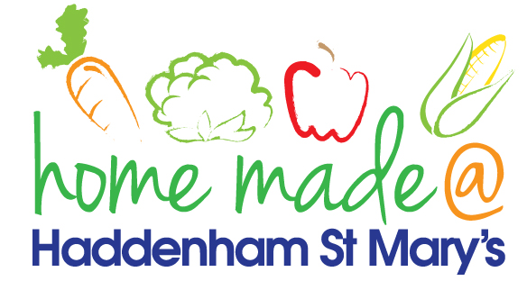

MENU – week 2
 | Monday  Around the World | Tuesday  Family  Favourites | Wednesday  Wonderful Roast | Thursday  Julie’s Jackets | Friday  Fish Friday
Lunch | Tomato and basil pasta bake with  garlic bread | Sausage roll, potato rosti and peas | Roast turkey with all the trimmings and gravy | Jacket potato with a choice of toppings | Fishcake, chips and sweetcorn
Vegetarian option | Tomato and basil pasta bake with garlic bread | Veggie sausage roll, potato rosti and peas | Falafel roast with all the trimmings | Jacket potato with a choice of toppings | Vegetable fingers, chips and sweetcorn
Dessert | Fruit cocktail | Trifle | Fresh fruit | Banana cake | Chocolate biscuit
Free From  option | Tomato and basil pasta bake  Fruit Cocktail | Sausage roll, potato rosti and peas  Mousse/Yoghurt | Roast turkey with all the trimmings and gravy  Fresh fruit | Jacket potato with a choice of toppings  Banana cake | Fish fingers, chips and sweetcorn  Homemade biscuit
All meals will contain or be served with at least one portion of vegetables.
All hot puddings will be accompanied by custard or cream.
All roast dinners, sausage & mash and pie dishes will have the option of extra gravy.
All children will also be offered bread, a piece of fruit and a drink of milk or water with their main meal.

