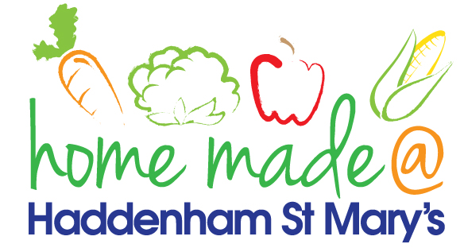

MENU – week 3
 | Monday  Around the world | Tuesday  Family  Favourites | Wednesday  Wonderful Roast | Thursday  Julie’s Jackets | Friday  Fish Friday
Lunch | Chicken curry and rice | Sausage, mash potato and vegetables | Roast beef with all the trimmings and gravy | Jacket potato with a choice of toppings | Fish burgers, potato lattice and peas
Vegetarian option | Vegetable curry and rice | Veggie sausage, mash potato and vegetables | Quorn roast with all the trimmings | Jacket potato with a choice of toppings | Vegetable slice, chips and peas
Dessert | Mandarin segments | Cheese cake | Fresh fruit | Carrot cake | Rock cake
Free From  option | Chicken curry and rice  Mandarin segments | Sausage, mash potato and vegetables  Mousse/yoghurt | Roast beef with all the trimmings and gravy  Fresh fruit | Jacket potato with a choice of toppings  Carrot cake | Fish fingers, chips and peas  Rock cake
All meals will contain or be served with at least one portion of vegetables.
All hot puddings will be accompanied by custard or cream.
All roast dinners, sausage & mash and pie dishes will have the option of extra gravy.
All children will also be offered bread, a piece of fruit and a drink of milk or water with their main meal.

