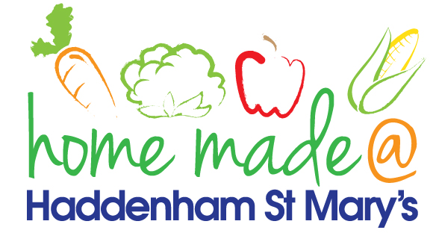

MENU – week 3
 | Monday  Around the world | Tuesday  Family  Favourites | Wednesday  Wonderful Roast | Thursday  Julie’s Jackets | Friday  Fish Friday
Lunch | Chicken balti, rice and naan bread | Cottage pie | Roast beef with all the trimmings and gravy | Jacket potato with a choice of toppings | Fishcake, chips and peas
Vegetarian option | Vegetable balti, rice and naan bread | Veggie cottage pie | Quorn roast with all the trimmings | Jacket potato with a choice of toppings | Vegetable slice, chips and peas
Dessert | Mandarin segments | Cheese cake | Fresh fruit | Toffee cake | Rock cake
Free From  option | Chicken balti, rice and naan bread  Mandarin segments | Cottage pie  Mousse/yoghurt | Roast beef with all the trimmings and gravy  Fresh fruit | Jacket potato with a choice of toppings  Toffee cake | Fish fingers, chips and peas  Rock cake
All meals will contain or be served with at least one portion of vegetables.
All hot puddings will be accompanied by custard or cream.
All roast dinners, sausage & mash and pie dishes will have the option of extra gravy.
All children will also be offered bread, a piece of fruit and a drink of milk or water with their main meal.

