DISHES AND THEIR ALLERGEN CONTENT – Homemade@Haddenham St Mary’sMAIN DISHES – Spring 2 2019
All free from menu options are free from gluten and dairy products – for further information please email homemade@haddenham-st-marys.bucks.sch.uk
DISHES | 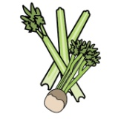 | 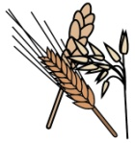 | 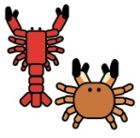 |  |  | 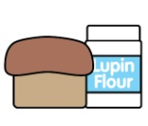 |  | 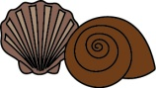 | 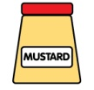 | 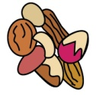 | 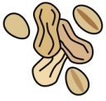 | 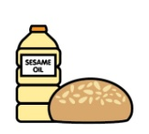
 | Celery | Cereals containing gluten | Crustaceans | Eggs | Fish | Lupin | Milk | Mollusc | Mustard | Nuts | Peanuts | Sesame seeds | Soya | Sulphur Dioxide
Chicken balti, rice and naan bread |  | ✓ |  | ✓ |  |  | ✓
Vegetable balti, rice and naan bread |  | ✓ |  | ✓ |  |  | ✓
Roast turkey dinner |  | ✓ |  | ✓ |  |  | ✓
Quorn roast dinner |  | ✓ |  | ✓ |  |  | ✓
Jacket potato with a choice of fillings |  |  |  |  | ✓ |  | ✓
Breaded plaice, potato rosti and vegetables |  | ✓ |  | ✓ | ✓ |  | ✓
Vegetable fingers, new potatoes/chips/ croquettes/rosti and vegetables |  | ✓ |  | ✓ |  |  | ✓
‘Free from’ fish fingers, new potatoes/chips/  croquettes and vegetables |  |  |  |  | ✓
DISHES
 | Celery | Cereals containing gluten | Crustaceans | Eggs | Fish | Lupin | Milk | Mollusc | Mustard | Nuts | Peanuts | Sesame seeds | Soya | Sulphur Dioxide
Sausage casserole |  | ✓ |  | ✓ |  |  | ✓ |  |  |  |  |  |  | ✓
Veggie sausage casserole |  | ✓ |  | ✓ |  |  | ✓ |  |  |  |  |  |  | ✓
Cod bites, croquettes and vegetables |  | ✓ |  | ✓ | ✓ |  | ✓
Vegetable bites, croquettes and vegetables |  | ✓ |  | ✓ |  |  | ✓
Roast beef dinner |  | ✓ |  | ✓ |  |  | ✓
Vegetable sausage roast dinner |  | ✓ |  | ✓ |  |  | ✓ |  |  |  |  |  |  | ✓
Sausage, mash and vegetables |  | ✓ |  | ✓ |  |  | ✓ |  |  |  |  |  |  | ✓
Veggie sausage, mash and vegetables |  | ✓ |  | ✓ |  |  | ✓ |  |  |  |  |  |  | ✓
Falafel roast dinner |  | ✓ |  | ✓ |  |  | ✓
Fish fingers, chips and vegetables |  | ✓ |  | ✓ | ✓ |  | ✓
Spaghetti Bolognese |  | ✓ |  | ✓ |  |  | ✓
Veggie spaghetti Bolognese |  | ✓ |  | ✓ |  |  | ✓
DISHES
 | Celery | Cereals containing gluten | Crustaceans | Eggs | Fish | Lupin | Milk | Mollusc | Mustard | Nuts | Peanuts | Sesame seeds | Soya | Sulphur Dioxide
Vegetable slice, chips and peas |  | ✓ |  | ✓ |  |  | ✓
Fishcake, chips and peas |  | ✓ | ✓ |  | ✓ |  | ✓
Chicken and sweetcorn pie, diced potatoes and veg |  | ✓ |  | ✓ |  |  | ✓
Vegetable pie, diced potatoes and veg |  | ✓ |  | ✓ |  |  | ✓
Macaroni cheese and garlic bread |  | ✓ |  | ✓ |  |  | ✓
Pizza, potato wedges and vegetables |  | ✓ |  | ✓ |  |  | ✓
Cottage pie |  |  |  |  |  |  | ✓
Veggie cottage pie |  |  |  |  |  |  | ✓

Review date: 25/1/19 |  | Reviewed by: | J Higgins |  | You can find this template, including more information at www.food.gov.uk/allergy

