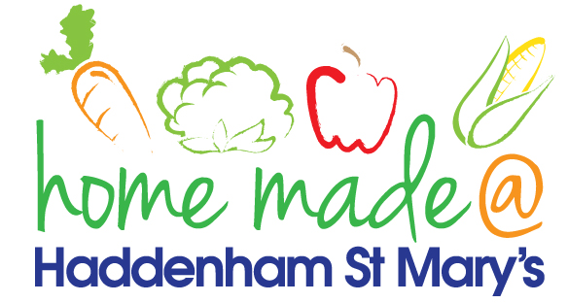

MENU – week 2
 | Monday  Around the World | Tuesday  Family  Favourites | Wednesday  Wonderful Roast | Thursday  Julie’s Jackets | Friday  Fish Friday
Lunch | Macaroni cheese and  garlic bread | Chicken and sweetcorn pie, diced potatoes and vegetables | Roast turkey with all the trimmings and gravy | Jacket potato with a choice of toppings | Breaded salmon, potato rosti and vegetables
Vegetarian option | Macaroni cheese and garlic bread | Vegetable pie, diced potatoes and vegetables | Falafel roast with all the trimmings | Jacket potato with a choice of toppings | Vegetable fingers, potato rosti and vegetables
Dessert | Fruit cocktail | Fruit Tiramisu | Fresh fruit | Chocolate and pear pudding | Fruit pinwheel
Free From  option | Macaroni cheese  Fruit Cocktail | Chicken pie, diced potatoes and vegetables  Mousse/Yoghurt | Roast turkey with all the trimmings and gravy  Fresh fruit | Jacket potato with a choice of toppings  Chocolate and pear pudding | Fish fingers, potato rosti and vegetables  Fruit pinwheel
All meals will contain or be served with at least one portion of vegetables.
All hot puddings will be accompanied by custard or cream.
All roast dinners, sausage & mash and pie dishes will have the option of extra gravy.
All children will also be offered bread, a piece of fruit and a drink of milk or water with their main meal.

