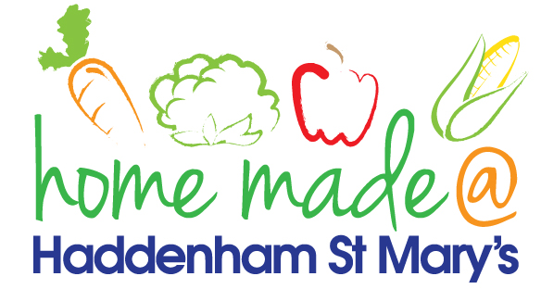

MENU – Week 1
 | Monday  Around the World | Tuesday  Family  Favourites | Wednesday  Wonderful Roast | Thursday  Julie’s Jackets | Friday  Fish Friday
Lunch | Pizza, potato wedges and vegetables | Sausage, mash and vegetables | Roast beef with all the trimmings and gravy | Jacket potato with a choice of toppings | Fish fingers, chips and vegetables
Vegetarian option | Pizza, potato wedges and vegetables | Veggie sausage, mash and vegetables | Quorn roast with all the trimmings | Jacket potato with a choice of toppings | Vegetable  fingers, chips and vegetables
Dessert | Mandarin segments | Raspberry and chocolate mousse cake | Fresh fruit | Apple crumble | Homemade biscuit
Free From  option | Pizza, potato wedges and vegetables  Mandarin segments | Sausage, mash and vegetables  Chocolate pudding | Roast beef with all the trimmings and gravy  Fresh fruit | Jacket potato with a choice of toppings  Apple crumble | Fish fingers, chips and vegetables  Biscuit
All meals will contain or be served with at least one portion of vegetables.
All hot puddings will be accompanied by custard or cream.
All roast dinners, sausage & mash and pie dishes will have the option of extra gravy.
All children will also be offered bread, a piece of fruit and a drink of milk or water with their main meal.

