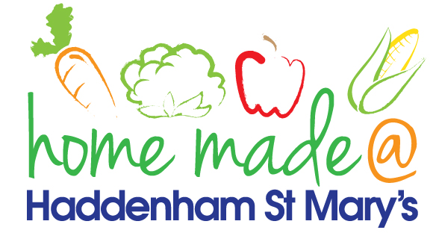

MENU – week 3
 | Monday  Around the world | Tuesday  Family  Favourites | Wednesday  Wonderful Roast | Thursday  Julie’s Jackets | Friday  Fish Friday
Lunch | Chicken chow mein and spring rolls | Pizza, potato wedges and vegetables | Roast beef with all the trimmings and gravy | Jacket potato with a choice of toppings | Scampi, chips and peas
Vegetarian option | Vegetable chow mein and spring rolls | Pizza, potato wedges and vegetables | Quorn roast with all the trimmings | Jacket potato with a choice of toppings | Vegetable slice, chips and peas
Dessert | Melon wedge | Trifle | Fresh fruit | Peach crumble | Apple muffin
Free From  option | Chicken chow mein and spring rolls  Melon wedge | Pizza, potato wedges and vegetables  Mousse/yoghurt | Roast beef with all the trimmings and gravy  Fresh fruit | Jacket potato with a choice of toppings  Peach crumble | Fish fingers, chips and peas  Cake/biscuit
All meals will contain or be served with at least one portion of vegetables.
All hot puddings will be accompanied by custard or cream.
All roast dinners, sausage & mash and pie dishes will have the option of extra gravy.
All children will also be offered bread, a piece of fruit and a drink of milk or water with their main meal.

