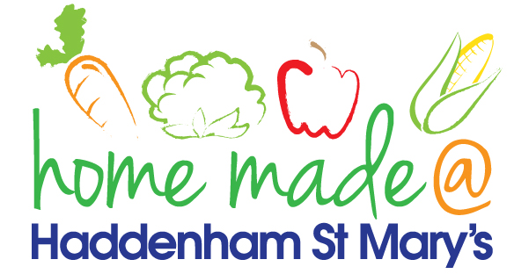

MENU – week 2
 | Monday  Around the World | Tuesday  Family  Favourites | Wednesday  Wonderful Roast | Thursday  Julie’s Jackets | Friday  Fish Friday
Lunch | Spaghetti bolognese and  garlic bread | Chicken goujons, potato croquettes and vegetables | Roast turkey with all the trimmings and gravy | Jacket potato with a choice of toppings | Breaded salmon, new potatoes and vegetables
Vegetarian option | Quorn spaghetti bolognese and garlic bread | Vegetable fingers, potato croquettes and vegetables | Falafel roast with all the trimmings | Jacket potato with a choice of toppings | Vegetable fingers, new potatoes and vegetables
Dessert | Peach | Mousse | Fresh fruit | Jam sponge | Flapjack
Free From  option | Spaghetti bolognese  Peach | Chicken goujons, new potatoes and vegetables  Mousse/Yoghurt | Roast turkey with all the trimmings and gravy  Fresh fruit | Jacket potato with a choice of toppings  Jam sponge | Fish fingers, new potatoes and vegetables  Flapjack
All meals will contain or be served with at least one portion of vegetables.
All hot puddings will be accompanied by custard or cream.
All roast dinners, sausage & mash and pie dishes will have the option of extra gravy.
All children will also be offered bread, a piece of fruit and a drink of milk or water with their main meal.

