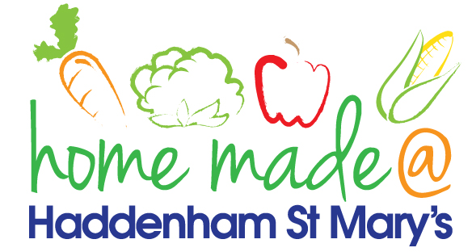

MENU – week 4
 | Monday  Around the world | Tuesday  Family  Favourites | Wednesday  Wonderful Roast | Thursday  Julie’s Jackets | Friday  Fish Friday
Lunch | Mexican beef and potato wedges | Hotdog, chips and vegetables | Roast turkey with all the trimmings and gravy | Jacket potato with a choice of toppings | Cod bites, potato croquettes and vegetables
Vegetarian option | Mexican Quorn and potato wedges | Veggie hotdog, chips and vegetables | Veggie sausage roast with all the trimmings | Jacket potato with a choice of toppings | Vegetable bites, potato croquettes and vegetables
Dessert | Peach | Low sugar apricot Eton mess | Fresh fruit | Pineapple cake | Ginger biscuit
Free From  option | Mexican beef and potato wedges  Peach | Hotdog, chips and vegetables  Mousse/yoghurt | Roast turkey with all the trimmings and gravy  Fresh fruit | Jacket potato with a choice of toppings  Cake/Biscuit | Fishfingers, potato croquettes and vegetables  Flapjack/Biscuit
All meals will contain or be served with at least one portion of vegetables.
All hot puddings will be accompanied by custard or cream.
All roast dinners, sausage & mash and pie dishes will have the option of extra gravy.
All children will also be offered bread, a piece of fruit and a drink of milk or water with their main meal.

