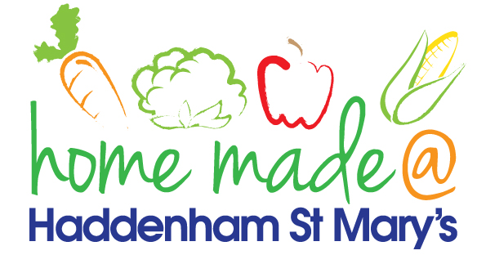

MENU – Week Commencing 3/9/18 (week 1)
 | Monday  Around the World | Tuesday  Family  Favourites | Wednesday  Wonderful Roast | Thursday  Julie’s Jackets | Friday  Fish Friday
Lunch |  |  |  | Jacket potato with a choice of toppings | Fish fingers, chips and vegetables
Vegetarian option |  |  |  | Jacket potato with a choice of toppings | Vegetable  fingers, chips and vegetables
Dessert |  |  |  | Fruit | Muffin
Free From  option |  |  |  | Jacket potato with a choice of toppings  Fruit | Fish fingers, chips and vegetables  Cake/Biscuit
All meals will contain or be served with at least one portion of vegetables.
All hot puddings will be accompanied by custard or cream.
All roast dinners, sausage & mash and pie dishes will have the option of extra gravy.
All children will also be offered bread, a piece of fruit and a drink of milk or water with their main meal.

