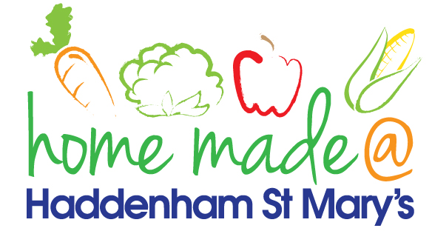

MENU – week 3
 | Monday  Around the world | Tuesday  Family  Favourites | Wednesday  Wonderful Roast | Thursday  Julie’s Jackets | Friday  Fish Friday
Lunch | Beef tagine | Sausage, mash and vegetables | Roast turkey with all the trimmings and gravy | Jacket potato with a choice of toppings | Scampi, chips and peas
Vegetarian option | Vegetable tagine | Veggie sausage, mash and vegetables | Quorn roast with all the trimmings | Jacket potato with a choice of toppings | Vegetable slice, chips and peas
Dessert | Melon wedge | Fruit jelly | Fresh fruit | Carrot cake | Homemade biscuit
Free From  option | Beef tagine  Melon wedge | Sausage, mash and vegetables  Jelly | Roast turkey with all the trimmings and gravy  Fresh fruit | Jacket potato with a choice of toppings  Cake/Biscuit | Fish fingers, chips and peas  Biscuit
All meals will contain or be served with at least one portion of vegetables.
All hot puddings will be accompanied by custard or cream.
All roast dinners, sausage & mash and pie dishes will have the option of extra gravy.
All children will also be offered bread, a piece of fruit and a drink of milk or water with their main meal.

