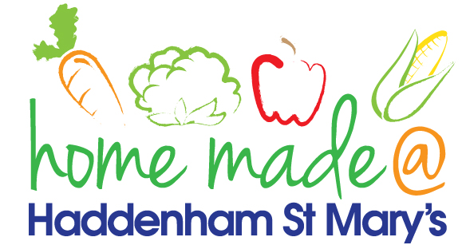

MENU – week 2
 | Monday  Around the World | Tuesday  Family  Favourites | Wednesday  Wonderful Roast | Thursday  Julie’s Jackets | Friday  Fish Friday
Lunch | Spaghetti bolognese | Mediterranean chicken | Roast beef with all the trimmings and gravy | Jacket potato with a choice of toppings | Breaded salmon, new potatoes and vegetables
Vegetarian option | Vegetable bolognese | Mediterranean vegetables | Falafel roast with all the trimmings | Jacket potato with a choice of toppings | Vegetable fingers, new potatoes and vegetables
Dessert | Peach | Strawberry Panacotta | Fresh fruit | Jam tart | Shortbread
Free From  option | Spaghetti Bolognese  Peach | Chicken breast, mash and vegetables  Mousse/Yoghurt | Roast beef with all the trimmings and gravy  Fresh fruit | Jacket potato with a choice of toppings  Cake/Biscuit | Fish fingers, new potatoes and veg  Biscuit
All meals will contain or be served with at least one portion of vegetables.
All hot puddings will be accompanied by custard or cream.
All roast dinners, sausage & mash and pie dishes will have the option of extra gravy.
All children will also be offered bread, a piece of fruit and a drink of milk or water with their main meal.

