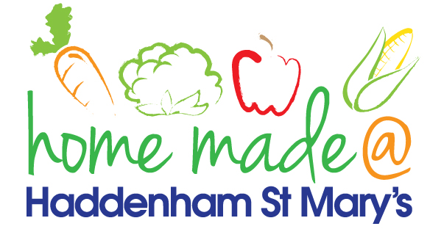

MENU – week 4
 | Monday  Around the world | Tuesday  Family  Favourites | Wednesday  Wonderful Roast | Thursday  Julie’s Jackets | Friday  Fish Friday
Lunch | Chilli, rice and nachos | Hot dog, chips and vegetables | Roast beef with all the trimmings and gravy | Jacket potato with a choice of toppings | Tuna pasta bake
Vegetarian option | Vegetable chilli, rice and nachos | Veggie hot dog, chips and vegetables | Veggie sausage roast with all the trimmings | Jacket potato with a choice of toppings | Vegetable pasta bake
Dessert | Peach | Strawberry panacotta | Fresh fruit | Raspberry muffin | Homemade biscuit
Free From  option | Chilli, rice and nachos  Peach | Hot dog, chips and vegetables  Yoghurt | Roast beef with all the trimmings and gravy  Fresh fruit | Jacket potato with a choice of toppings  Flapjack/biscuit | Tuna pasta bake  Biscuit
All meals will contain or be served with at least one portion of vegetables.
All hot puddings will be accompanied by custard or cream.
All roast dinners, sausage & mash and pie dishes will have the option of extra gravy.
All children will also be offered bread, a piece of fruit and a drink of milk or water with their main meal.

