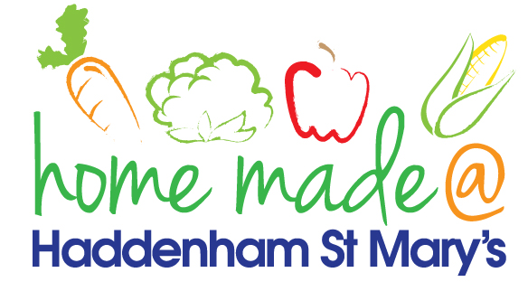

MENU – week 4
 | Monday  Around the world | Tuesday  Family  Favourites | Wednesday  Wonderful Roast | Thursday  Julie’s Jackets | Friday  Fish Friday
Lunch | Spaghetti Bolognese and garlic bread | Chicken and sweetcorn pie | Roast beef with all the trimmings and gravy | Jacket potato with a choice of toppings | Scampi, chips and peas
Vegetarian option | Vegetable pasta and garlic bread | Vegetable pie | Veggie sausage roast with all the trimmings | Jacket potato with a choice of toppings | Vegetable fingers, chips and peas
Dessert | Peach | Cheesecake | Fresh fruit | Fruity flapjack | Lemon cake
Free From  option | Spaghetti Bolognese  Peach | Chicken and sweetcorn pie  Yoghurt | Roast beef with all the trimmings and gravy  Fresh fruit | Jacket potato with a choice of toppings  Fruity flapjack | Fish fingers, chips and peas  Biscuit
All meals will contain or be served with at least one portion of vegetables.
All hot puddings will be accompanied by custard or cream.
All roast dinners, sausage & mash and pie dishes will have the option of extra gravy.
All children will also be offered bread, a piece of fruit and a drink of milk or water with their main meal.

