DISHES AND THEIR ALLERGEN CONTENT – Homemade@Haddenham St Mary’sMAIN DISHES – Summer 2 2017
All free from menu options are free from gluten and dairy products – for further information please email homemade@haddenham-st-marys.bucks.sch.uk
DISHES | 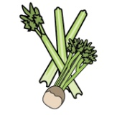 | 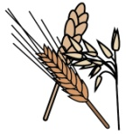 | 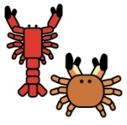 | 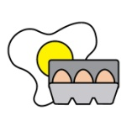 | 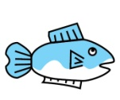 | 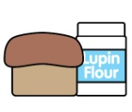 | 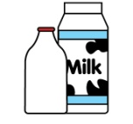 | 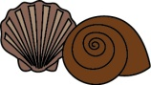 |  | 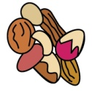 | 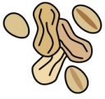 | 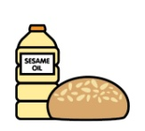 | 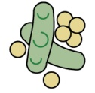 | 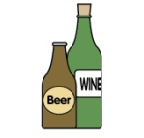
 | Celery | Cereals containing gluten | Crustaceans | Eggs | Fish | Lupin | Milk | Mollusc | Mustard | Nuts | Peanuts | Sesame seeds | Soya | Sulphur Dioxide
Beef burger, chips and coleslaw |  | ✓ |  | ✓ |  |  | ✓
Veggie burger, chips and coleslaw |  |  |  | ✓ |  |  | ✓
Roast turkey dinner |  | ✓ |  | ✓ |  |  | ✓
Quorn roast dinner |  | ✓ |  | ✓ |  |  | ✓
Jacket potato with a choice of fillings |  |  |  |  | ✓ |  | ✓
Breaded fish, new potatoes and vegetables |  | ✓ |  |  | ✓
Vegetable fingers, new potatoes vegetables |  | ✓ |  | ✓
‘Free from’ fish fingers, new potatoes and vegetables |  |  |  |  | ✓
DISHES
 | Celery | Cereals containing gluten | Crustaceans | Eggs | Fish | Lupin | Milk | Mollusc | Mustard | Nuts | Peanuts | Sesame seeds | Soya | Sulphur Dioxide
Pizza, potato wedges and vegetables |  | ✓ |  |  |  |  | ✓
Sausages, new potatoes and vegetables |  | ✓
Roast beef dinner |  | ✓ |  | ✓ |  |  | ✓
Vegetable sausage roast dinner |  | ✓ |  | ✓ |  |  | ✓ |  |  |  |  |  |  | ✓
Fish burger, potato wedges and vegetables |  | ✓ |  |  | ✓
Veggie burger, potato wedges and vegetables |  | ✓
‘Free from’ fish fingers, potato wedges and vegetables |  |  |  |  | ✓
Tomato pasta bake, garlic bread and salad |  | ✓ |  |  |  |  | ✓
Taco, rice and salad |  | ✓
‘Free from’ wraps, rice and salad
Salmon and broccoli fishcake, potato rosti and vegetables |  | ✓ |  | ✓ |  |  | ✓
DISHES
 | Celery | Cereals containing gluten | Crustaceans | Eggs | Fish | Lupin | Milk | Mollusc | Mustard | Nuts | Peanuts | Sesame seeds | Soya | Sulphur Dioxide
Cheese and onion slice, potato rosti and vegetables |  | ✓ |  | ✓ |  |  | ✓
‘Free from’ tuna pasta bake |  |  |  |  | ✓
Spaghetti Bolognese and garlic bread |  | ✓ |  |  |  |  | ✓
Vegetable pasta and garlic bread |  | ✓ |  |  |  |  | ✓
‘Free from’ spaghetti bolognese
Chicken and sweetcorn pie |  | ✓ |  |  |  |  | ✓
Vegetable pie |  | ✓ |  |  |  |  | ✓
‘Free from’ chicken and sweetcorn pie
Scampi, chips and peas |  | ✓ | ✓ |  | ✓ |  | ✓
Vegetable fingers, chips and peas |  | ✓ |  | ✓
Chicken and chorizo paella |  | ✓
Vegetable paella |  | ✓
‘Free From’ Fish fingers, chips and peas |  |  |  |  | ✓

Review date: | 23/06/17 | Reviewed by: | J Higgins | 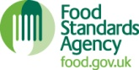 | You can find this template, including more information at www.food.gov.uk/allergy

